Mildred Suriel

Intro Info Tech

Week 12 - Spreadsheets and Databases

April 27th, 2019

Spreadsheets and Database

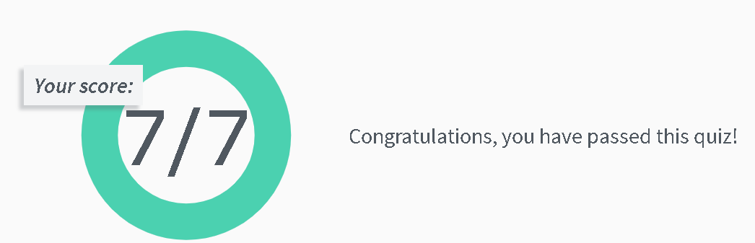Spreadsheets Quiz Score

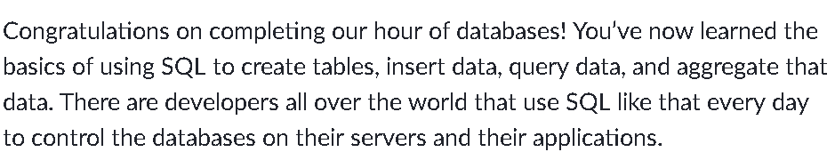SQL 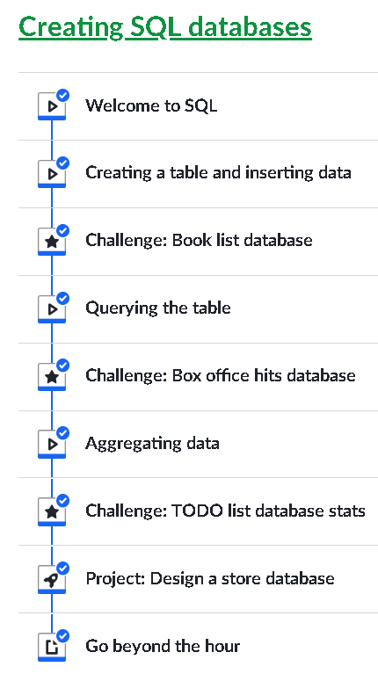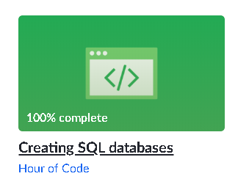Databases